Description des noms utilisés pour la PlateformeAutoML

Fonction de prétraitement des données

- Encodage
- OneHotEncoder
- OrdinalEncoder
- LabaleEncoder

- Normalisation
- StandardScaler
- MinMaxScaler
- MaxAbsScaler
- RobustScaler

- Imputation
Les differentes trategies
- mean
- median
- most_frequent
- constant

remarque : if When strategy == “constant”, fill_value is used to replace all occurrences of missing_values.

ILLUSTRATION

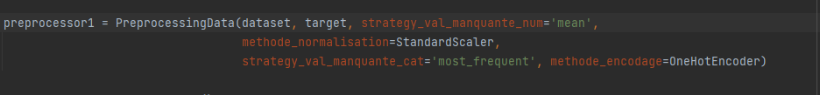

Algorithme de classification
Les ALGOS utilisées pour le moment :
"RandomForest"
"AdaBoost"
"SVM"
"KNN"
"Logistic":
"MLP"
"LDA"
"Binary_tree”

Illustration

RandomForest = make_pipeline(preprocessor, RandomForestClassifier(random_state=0))
AdaBoost = make_pipeline(preprocessor, AdaBoostClassifier(random_state=0))
SVM = make_pipeline(preprocessor, SVC(random_state=0))
KNN = make_pipeline(preprocessor, KNeighborsClassifier())
Logistic = make_pipeline(preprocessor, LogisticRegression(random_state=0))
MLP = make_pipeline(preprocessor, MLPClassifier())
LDA = make_pipeline(preprocessor, LinearDiscriminantAnalysis())
Binary_tree = make_pipeline(preprocessor, tree.DecisionTreeClassifier())

